

Common Meter reading Instrument (CMRI) _G-12L

APPLICATION  THAT  EMPOWER | 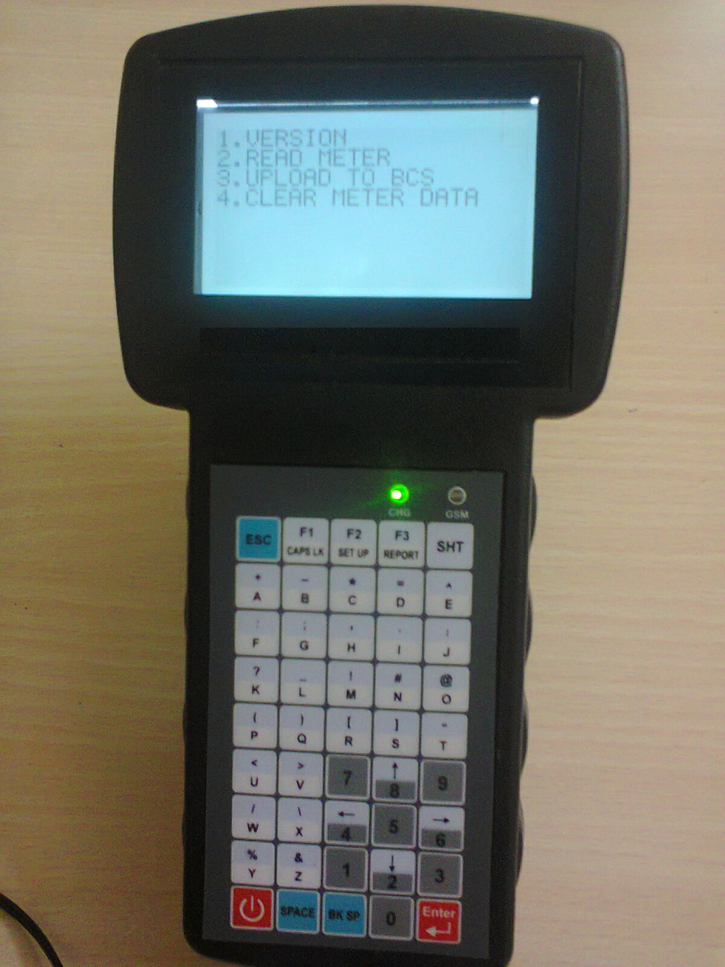

Overview:

The core benefit of device G-12L is user programmable and has facility to interface meter reading APIs as per user requirement like Secure, L&T, Elster, Genus, L&G, HPL socomec and Allied make of meters and customizes to user specification.

The CMRI device designed for Fast, accurate and reliable, delivers world-class performance with highly integrated and advanced architecture.

Meter Interface: Supports wireless communication interface like unlicensed Sub-GHz 868MHz/2.4GHz Zigbee radio frequency bands, and wired communication interface port like RS232/Optical to communicate with energy meters

Server PC Interface: Supports wireless GSM/GPRS based communication provided and wired communication RS232/USB port with separate ESD protection to communicate with server PC and optional wireless interfaces are GSM/GPRS, Blue Tooth, Wi-Fi.

ARM Cortex -A8 CPU
GSM / GPRS/Wi-Fi/BT
Linux/Android OS
Optical /IR/USB/RS232

Specifications
Processor | ARM Cortex-A8 1GHz
Display | 3.5” QVGA TFT LCD
Memory | 512 MB Flash memory, 512 MB DDR3, 2MB SPI flash, up to 32GB micro SD card
Operating System | Linux ,kernel v2.6.37
Communication Interfaces | - RS-232  - USB  - IR/IRDA
Optional &customizations | - GSM/GPRS  - Blue Tooth.  - Wi-Fi 802.11 b/g/n.  - GPS.  - Zigbee 2.4GHz/ Sub-GHz 868MHz.  - Camera 5 Mega Pixel.  - Custom Keypad  - Customized Software
Keypad | Membrane type - 45 keys.
Power Adaptor | AC Input 100-240V ±30 %, 50Hz ±10%, DC output 10.5V, 2.5Amp
LED Indications | Power/GSM N/W, battery status
Battery | Rechargeable Li-ion 7.4V/2.2Ah
Enclosure | ABS+PC
Temperature | Operating: 0º to 50ºC.  Storage: -20º to 70ºC
Humidity | 95% RH non condensing
EMI/EMC and Type tests | Comply as per IEC/IS standards
Dimensions | 238 x 45 x 108 mm ( L x H x W)
Weight | 400 grams
Accessories | Power adaptor ,common optical port, USB cable,RS232 cable, carrying case

Salient Features:

- Fast-Versatile-Intelligent affordable Security Lock, Rugged ABS Plastic enclosure.
- Compact - Low cost –Rugged - Light weight and dust Tolerant
- Intelligent and fast battery charger.
- Operates on AC-DC Adapter (10V, 1A) & 7.4V, 2.2 AH LI-ion Battery.

a) Field architecture
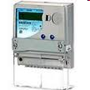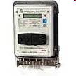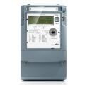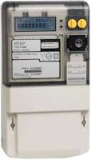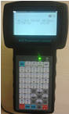
I
I
I
I
LPR/ZIGBEE
R232/OPTICAL/IR
G-12S
Meter 1
Meter 2
Meter 3
Meter n

b) System architecture 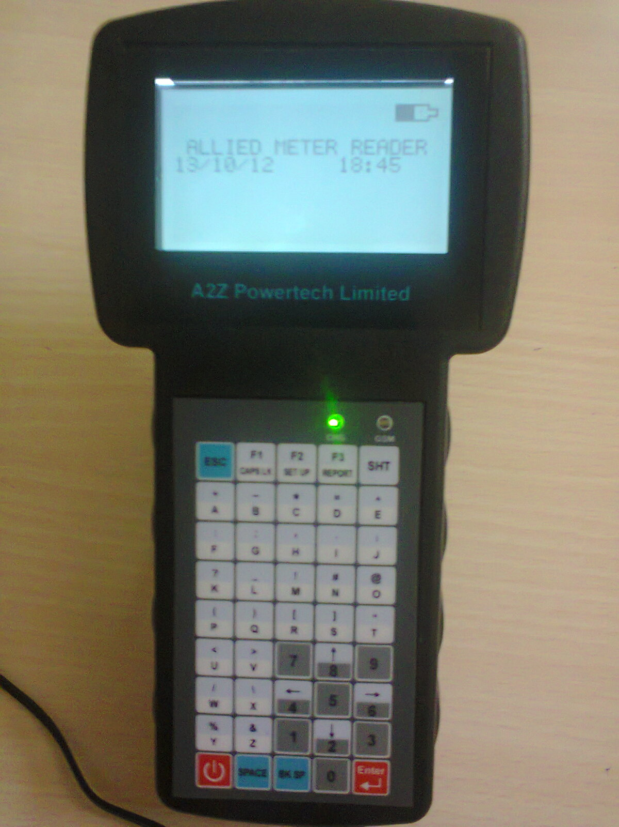
U
S
B
U
S
B
U
S
B
U
S
B
G
S
M
/
G
P
R
S
G
S
M
/
G
P
R
S
G
S
M
/
G
P
R
S
G
S
M
/
G
P
R
S
FIREWALL
APPLICATION
SERVER
DATABASE
SERVER
USER
G-12S
G-12S

G-12S

G-12S

I
I
I
I
I
I
I

GVM Electronic Systems.

Registered office:  502, Sri sai land mark, Block-A  Street No-8,Habsiguda  Hyderabad - 500007,  Telangana (INDIA).  Website : www.gvmgroup.co.in |  | R&D Center:  1-7-9/3, Level 1 Harihara Estates,  Opp ISI, Street No. 8,Habsiguda,  Hyderabad - 500007  Andhra Pradesh (INDIA)  Tel : 040 – 40073218.

